Heterogeneous flows foster heterogeneous assemblages: relationships between functional diversity and hydrological heterogeneity in riparian plant communities.
James R. Lawson*¹, Kirstie A. Fryirs², Michelle R. Leishman¹

- Department of Biological Sciences, Macquarie University, North Ryde, NSW 2109, Australia
- Department of Environmental Sciences, Macquarie University, North Ryde, NSW 2109, Australia
* james.lawson@mq.edu.au, fax: +61 2 9850 8245, phone: +61 2 9850 8160

Running title: “Hydrological variability associated with higher riparian plant functional diversity”
Keywords: ecohydrology, riparian vegetation, functional trait, functional diversity, environmental heterogeneity

SUMMARY
1.) Riparian ecosystems are biophysically complex and highly diverse taxonomically, structurally and functionally. While many environmental factors determine the structure and function of riparian vegetation communities, hydrology is thought to be the ‘master variable’. Flooding and variability in water availability are known to be key drivers of taxonomic diversity, but their influence on the functional composition of riparian vegetation communities remains largely unexplored.
2.) We collected data on species abundance, quantitative plant functional traits and hydrology from 15 sites distributed across south-eastern Australia in order to address the following questions: a.) is functional diversity related to frequency and magnitude of flooding disturbance?, and b.) is functional diversity related to variability in seasonal water availability within the riparian zone?
3.) We were able to confirm that metrics describing both flooding disturbance and patterns of water availability exhibit strong relationships with functional diversity within riparian vegetation communities of south-eastern Australia. The key finding of this study is that functional diversity in these systems tends to be positively associated with variability in hydrological conditions and the intensity of rare, high magnitude flooding events, rather than averagepatterns of flow.
4.) Our study highlights the importance of extreme flooding events and temporal patterns of water availability as determinants of diversity in riparian vegetation. These relationships may have significant consequences for plant communities experiencing alterations to hydrology caused by anthropogenic flow modification and the changing climate.

INTRODUCTION
Riparian ecosystems are biophysically complex and highly diverse taxonomically, structurally and functionally (Naiman, Decamps & Pollock 1993; Poff 2002; Nilsson & Svedmark 2002). Extensive flow regulation of river systems and changing patterns of runoff under future climates are likely to produce dramatically different future hydrologies, with significant consequences for the diversity and functional composition of riparian assemblages. Riverine conservation and rehabilitation efforts must therefore be informed by general understanding of the processes that generate patterns of diversity and drive ecosystem functioning in riparian ecosystems.
The prevailing paradigm in riparian ecology holds that heterogeneity in the riparian patch mosaic results from the sculpting action of hydrological processes across the biogeomorphic template (Tabacchi et al. 1996; Naiman & Decamps 1997; Palmer & Poff 1997; Stromberg 2001; Corenblit et al. 2007; Bornette et al. 2008; Steiger & Corenblit 2012). In riparian environments, it is this intrinsic environmental heterogeneity which fosters structural, taxonomic and functional heterogeneity within vegetation communities (Naiman et al. 1993; Corenblit et al. 2007; Bornette et al. 2008). Local hydrology is widely considered to be the most important determinant of community composition and function in riparian plant assemblages, as it dictates patterns of disturbance by flooding, as well as soil moisture availability (Poff, Allan & Bain 1997; Arthington et al. 2010). Flooding may retard competitive exclusion by resetting the patch structure of parts of the landscape and thereby enhance diversity (Huston 1979; Naiman et al. 1993), or constrain assemblages to species which have ecological strategies adapted to flooding, thereby decreasing diversity (Díaz, Cabido & Casanoves 1998).
The literature describing relationships between hydrology and riparian plant taxonomic diversity is relatively mature. General support has been found for the intermediate disturbance hypothesis (Connell 1978) which describes the relationship between flooding intensity and taxonomic diversity (e.g. Bendix 1997; Bendix & Hupp 2000; Lite, Bagstad & Stromberg 2005; Corenblit et al. 2007). This support is not equivocal however (Nilsson et al. 1989; Baker 1990) and at within-reach scales the geomorphic template is also a strong control on diversity (Bendix 1997, O’Donnell et al. 2013). In regions where riparian plants experience periodic water stress, soil moisture availability may be driven largely by hydrology (Castelli, Chambers & Tausch 2000; Nilsson & Svedmark 2002). Seasonal and interannual variability in patterns of disturbance and water availability are also known to influence species richness (Greet, Angus Webb & Cousens 2011; Catford et al. 2012, 2014) and this effect may be exacerbated for summer flows in hot or dry regions (Garssen, Verhoeven & Soons 2014). A study investigating drivers of riparian vegetation community structure and composition in subtropical eastern Australia identified variability in dry season flows as the hydrological variable which was most strongly associated with variation in species richness (Arthington et al. 2012).
Conservation and ecological restoration activities increasingly aim to preserve the ecosystem functions associated with plant biodiversity (Aerts & Honnay 2011; Cadotte, Carscadden & Mirotchnick 2011; Montoya, Rogers & Memmott 2012). Plant functional traits can form the basis for mechanistic assessments of diversity that describe the range and distribution of ecological strategies within a community. Such metrics of functional diversity are substantially more powerful than taxonomic metrics as indicators of ecosystem functioning, ecosystem resilience and capacity to provide ecosystem services (Tilman et al. 1997; Dı́az & Cabido 2001; Hooper, Iii & Ewel 2005). Reduced abundance of functionally unique species may gradually undermine ecosystems and therefore assessment of functional diversity can be useful to diagnose degradation before species loss occurs (Mouillot et al. 2013). Assessments of ecosystem service production have also begun to give functional diversity privilege over taxonomic metrics (Díaz & Lavorel 2007).
Numerous metrics of functional diversity have been described in the literature (Schleuter & Daufresne 2010; Mouillot et al. 2013). These metrics aim to describe "the distribution of species and their abundances in the functional space of a given community” (Mouillot et al. 2013; pp.XXXX) and typically process multidimensional trait data to output a single value describing various properties of these data. The framework described by Villéger, Mason & Mouillot (2008) consisting of functional richness (the volume of the convex hull circumscribing the range of trait values), functional divergence (divergence in the distribution of abundance within traitspace) and functional evenness (the evenness of this distribution in traitspace) to describe functional diversity (e.g. Biswas & Mallik 2010; Pakeman 2011; Savage & Cavender-Bares 2012; Clark et al. 2012). Functional dispersion (FDis), defined as the abundance-weighted mean distance of individual species to the centroid of all species in the community, represents an improvement on this framework (Laliberte& Legendre 2010). FDis allows for consideration of species’ abundances while integrating functional richness and functional divergence and is independent of species richness by construction, alleviating concerns that it merely tracks patterns of species richness (as is possible with functional richness). FDis is also known to be more robust to bias due to missing trait data than metrics such as functional richness, evenness or divergence (Pakeman 2014). In an empirical assessment of specific functional diversity metrics as indicators of ecosystem functioning in a Minnesota grassland, FDis was a useful predictor of all three measured traits (above and belowground biomass production and light capture) and compared favourably with other metrics (Clark et al. 2012).
Considerably less is known about drivers of functional diversity than of taxonomic diversity in riparian plant communities. Catford et al.(2011) showed how flow impoundment along a large river system in south-eastern Australia was associated with greater cover of exotic species and reduced functional diversity in riparian wetlands. However their study used multiple univariate metrics of diversity to support its findings rather than a multivariate index. Support for the intermediate disturbance hypothesis with respect to functional diversity has been described in communities along a gradient of disturbance associated with management for logging (Biswas & Mallik 2010). Similarly in agricultural systems, land use intensification has been linked with lower functional diversity across an international dataset (Laliberté et al. 2010) and the authors associated this effect with a reduced ability of communities to respond to disturbance. On the west coast of Scotland, increasing anthropogenic disturbance in arable fields, grazed grasslands, moorlands and woodlands was associated with reduced functional richness and increased functional evenness (Pakeman 2011). A trend is apparent from these studies where functional diversity is inversely associated with human-induced environmental homogenisation. At a meeting of the North American Benthological Society in 1995, the attendees of a symposium on ecological heterogeneity urged stream researchers to “examine heterogeneity from a functional perspective” (Palmer & Poff 1997). Progress on this front has been sparse, and describing the influence of hydrological heterogeneity on riparian functional diversity would represent a significant advancefor riparian ecology and ecosystem-oriented riparian conservation.
We hypothesised that the environmental heterogeneity induced by repeated floods and fluctuating soil moisture levels should be reflected in the functional composition of plant communities adapted to the riparian environment. To this end, we investigated the relationship between hydrologically driven environmental heterogeneity and functional diversity in riparian plant communities, using south-eastern Australia as a case study where a broad spectrum of hydrological heterogeneity is present within a relatively compact, contiguous landscape (Finlayson & McMahon 1988; Peel, McMahon & Finlayson 2004).
Specifically, we asked the following questions:
- Is functional diversity related to the frequency and magnitude of flooding disturbance?
- Is functional diversity related to variability in seasonal water availability in the riparian zone?

METHODS
Study sites
Fifteen riparian sites were selected along gauged rivers within the South-East Coast and south-eastern Murray Darling drainage basins of Australia.These sites were distributed across clear gradients of ecologically relevant dimensions of hydrological variation: specifically, the magnitude, frequency, duration, timing and rates of change of flow events and patterns. The study area spanned latitude -29.467 to -37.371 and longitude 147.413 to 152.217. Sites spanned an altitudinal range of 23 – 732 m above sea level. Site-specific details can be found in the Supporting Information (S1). The reader is referred to Lawson et al. (in press.) for a description of site selection criteria and vegetation survey methods, as this study was undertaken simultaneously and at the same sites.

Rationale for trait selection
Data for the following traits were collected: specific leaf area (SLA), maximum canopy height, seed mass, wood density, flowering period length (proportion of the year spent in flower) and leaf narrowness (the ratio of leaf width to length). These traits were chosen to encapsulate the key axes of variation relevant to ecological strategies employed by riparian plants.

Specific leaf area, maximum canopy height and seed mass comprise the LHS (leaf, height, seed) triad of traits introduced by Westoby (1998) as a general scheme for comparing the properties of vegetation communities. These three traits are typically distributed orthogonally from each other and represent fundamental trade-offs that control plant ecological strategy (Westoby et al. 2002).

Specific leaf area (the ratio of one-sided leaf area to oven dry mass) is a useful indicator of a species’ position along the leaf economics spectrum (Wright et al. 2004). High SLA species invest considerable nutrients in their leaves, have high rates of photosynthesis and respiration and short leaf longevity. These species typically exhibit high relative growth rates. Conversely, low SLA species receive slower return on investment on costly leaves, with lower rates of photosynthesis and respiration but greater leaf longevity and ability to tolerate stressful conditions (Reich & Wright 2003; Wright et al. 2004).

Maximum canopy height integrates the central trade-off between competition for light and construction and maintenance of costly support structures such as woody stems (Westoby 1998). These costs are particularly accentuated where plants must defend stems from mechanical disturbance, for example, flowing water (Falster 2006).

Seed mass, defined here as the combined mass of the seed coat, endosperm and embryo, but excluding dispersal structures, indicates maternal investment in offspring and is a fundamental determinant of seedling establishment success (Leishman et al. 2000). In the riparian environment seed mass may influence hydrochorous dispersal (Carthey et al. in review) and ability for plant establishment under different soil moisture conditions (Leishmanet al. 2000).

Wood density, defined as oven dry mass divided by green volume, is an emergent property that integrates a number of anatomical traits of lignified tissues (Chave et al. 2009). Dense wood confers mechanical strength to stems (Niklas & Spatz 2010) but is costly to construct. High wood density has been linked with slower relative growth rates but increased cohort survivorship (e.g. King et al. 2006; Poorter et al. 2008; Kraft et al. 2010; Wright et al. 2010). Wood density has also been associated with environmental stress tolerance (Preston, Cornwell & Denoyer 2006; Martínez-Cabrera et al. 2009) and enhanced resistance to wind (Telewski 1995; Curran et al. 2008) and flooding disturbance (Lawsonet al. in review). These latter two associations are significant in riparian environments, where pulsed periods of water stress and flooding are commonplace. Wood density provides an indication of the trade-offs associated with ecological strategies used by plants to cope with these conditions.

Patterns of seasonality across south-eastern Australia are variable both spatially and temporally, owing to complex interactions between geography and decadal-scale oscillations in climate driven by the Pacific Decadal Oscillation and El Nino Southern Oscillation (Nicholls 1989; Peel, Finlayson &McMahon 2007; Ward et al. 2010). The lack of a strong period of cold-induced dormancy in this region means plants may flower at any time of the year. Flowering period length was used here as an indicator of species’ ability to respond reproductively to favourable conditions, for example, conditions offered by water availability.

Leaf narrowness provides two-fold information about plant ecological strategy. Firstly, narrow leaves are able to regulate temperature more efficiently and thus maintain photosynthesis in hot, dryor highly insolated (i.e. consistent with disturbed) conditions (Cornelissen et al. 2003). Leaf narrowness is also strongly indicative of rheophyty – the trait syndrome shared by plants adapted to growing near swift flowing, frequently flooded streams (van Steenis 1981).

Trait dataset assembly
The dataset for this study was assembled using measurements recorded in the field (SLA, wood density), supplemented by data from published literature, private and public trait databases and Australian flora texts; see the Supporting Information (S2) fora detailed bibliography of references for data. In the case that multiple values were found in the literature or online for a trait, values were excluded if they were measured from sites that were environmentally different to the field sites in this study. Remaining values were averaged. Single values for each trait were recorded, under the assumption that intraspecific variability is less than interspecific variability (Michaels, Benner & Hartgerink 1988; Westoby 1998) and that we are interested in functional variation driven by variation among species. Leaf narrowness was not included for grasses, while seed mass and length of flowering period were not included for ferns.

SLA was measured once for each species according to the procedure defined by Cornelissen (2003). A minimum of five new but fully mature leaves from well-lit areas were taken from each of five non-contiguous individuals. Leaves were pressed in the field to maintain fresh area and allowed to air dry at 20-45°C, then scanned and leaf area measurements made using image analysis software (ImageJ 1.48 for Windows). Leaves were then oven dried at 70°C for 72 hours and weighed using a microbalance (Mettler Toledo, Greifensee, Switzerland). SLA was then calculated as one-sided fresh area divided by oven dry mass.
Wood density data was collected according to the procedure outlined in Lawsonet al. (in press). Site-specific values were available for wood density but for the purposes of this study an overall mean value was calculated for species which occurred at multiple sites. Wood density values for species for which data could not be obtained in the field were obtained from the Global Wood Density Database (Chave et al. 2009).

Hydrological analysis
Daily discharge data for each site were obtained from the PINNNENA CW 10.1 database (NSW Office of Water, Department of Primary Industries) and the New South Wales (NSW) Office of Water Continuous Water Monitoring network website (http://realtimedata.water.nsw.gov.au/water.stm) for NSW sites, and the Victoria State Government’s Water Measurement Information System website (http://data.water.vic.gov.au/monitoring.htm) for Victorian sites. Thirty year time series spanning 1983 – 2012 were obtained where possible, although three sites had truncated records of 15, 19 and 28 years. Missing data were approximated by multiple linear regression (4 sites) and linear interpolation (1 site) using the Time Series Manager module in River Analysis Package (Marsh, Stewardson & Kennard 2003). We used the Time Series Analysis module in River Analysis Package to generate a set of23 hydrological metrics for each site, based on a reduction of the minimally redundant set of ecologically relevant metrics for Australian rivers described by Kennard et al. (2010). These metrics were chosen as descriptors of the frequency and magnitude of flooding disturbance, as well as variability in water availability across seasons and between years (see Table 1for descriptions of individual metrics). Parameters used to generate hydrological metrics were identical to Lawsonet al. (in press); the reader is referred to this publication for further detail. Summary statistics for hydrological metrics are shown in the Supporting Information (S1). Metrics of flow magnitude which had units ML/day were standardised by mean daily flow to allow for comparison between different river channel sizes. These metrics therefore represent ratios of flow magnitude to mean daily flow.

Functional diversity analysis
We used the dbFD function from the FD package for R (Laliberté & Legendre 2010) to calculate abundance-weighted functional dispersion (FDis). This package implements the method for distance-based tests for homogeneity of multivariate dispersions described by Anderson (2006). dbFD uses Gower's method(1971) to generate the dissimilarity matrix, which can account for missing values, and automatically standardises traits by their ranges; Cailliez’s correction was applied to the matrix (Cailliez 1983). Simpson’s diversity was calculated using the SYNCSA package (Debastiani & Pillar 2012).
Only species present at >1 % cover in plots were included in the analysis (n=126, from a total of 327 species). Data deficient species lacking values for more than four traits could not be included in the analysis as they produced gaps in the distance matrix used to calculate functional diversity. Thus a final total of 107 species were included in the analysis. Data density exceeded 90% for all sites and averaged 97%; full data density information including trait specific values are shown in the Supporting Information (SP1). All trait values were transformed by log₁₀ prior to analysis. Summary statistics for the trait dataset are also available in the Supporting Information (S1).
Following Leps, Bello, Lavorel, & Berman, (2006), we performed principal components analysis (PCA) (stats package, R Core Team 2013) on trait data to check for redundancy. Although not completely orthogonal, traits were well distributed across multiple principal components. Therefore we believe there is both ecological (as previously discussed) and statistical rationale to retain all six traits in the analysis.
All statistical analyses were performed using the R statistical programming environment (R Core Team 2013). The R code used for these analyses can be retrieved from https://github.com/jamesrlawson/functional-diversity/tree/master/scripts. Statistical significance was interpreted at alpha = 0.05.

Relationships between FDis and hydrological metrics and taxonomic diversity
Ordinary least-squares (OLS) regression models were generated for the selected metrics to determine relationships between hydrological gradients and FDis. To reduce the occurrence of Type 1 statistical error, we adjusted the resulting p values using the two-step Benjamini - Hochberg (BH) procedure (Benjamini, Krieger & Yekutieli 2006) for controlling the false discovery rate (mt.rawp2adjpfunction in multtest package for R) (Pollard, Ge & Dudoit 2008). This two-step BH method has been shown to control the false discovery rate for positively dependent test statistics and provides a better estimate of the false discovery rate than the original BH algorithm (Benjamini & Hochberg 1995) by adaptively controlling p value adjustment according to the number of true null hypotheses obtained from the first pass of the procedure.
The utility of functional diversity metrics depends on their ability to provide non-redundant information compared with measures of taxonomic diversity. To this end we further tested relationships (using OLS regression) between FDis and species richness and Simpson’s diversity (for species used in the analysis, present at >1 % cover), and species richness for the full set of 327 species identified in the study.
We selected a minimal multiple regression model designed to incorporate descriptors of disturbance frequency and magnitude andvariability in seasonal flow. The full set of hydrological metrics was initially screened to remove metrics which were individually determined to have non-significant relationships with FDis. PCA over the selected metrics identified one major and two minor axes of variation (PC1 – 71.4%, PC2 – 9.0 % and PC3 - 8.3 % of variance explained). For PC1 there was no clear differentiation in eigen values; the metric with highest individual R² value (interannual variability in high flows) was selected. PC2 identified mean daily flow in summer and PC3 identified interannual variability in flood frequency as further sources of variability. Models were then built pertaining to all possible permutations of summation and interaction for these three metrics. Values for each metric were centred by subtracting the mean value (after Robinson & Schumacker, 2009). Multicollinearity was tested for according to the variance inflation factor (VIF) score (HH package, Heiberger & Holland, 2004) and models were compared according the second order of Akaike’s Information Criterion (AIC) (MuMIn package for R, Barton, 2012). Second order AIC is recommended in order to reduce bias when the ratio of sample size to number of predictor variables is small (Burnham & Anderson 2002).

RESULTS
Below we describe patterns of variation in functional dispersion (FDis) as they relate to the hydrological metrics described in Table 1. All models are linear apart from M_MinM and CVMDFSummer, for which a quadratic model (df = 2,12) provided a substantially better fit. Statistics for all univariate regression models are presented in the Supporting Information (S1).

Is functional diversity related to the frequency and magnitude of flooding disturbance?
Functional dispersion was positively associated with metrics describing intense but rare episodes of flooding disturbance. FDis was significantly associated with the magnitude of the 20 year average return interval flood (AS20YrARI, Fig. 1a, adjusted p = 0.0278, R² = 0.377). FDis was also significantly associated with interannual variability in high flow magnitude (CVAnnHSPeak, Fig. 1b, adjusted p = 0.0152, R² = 0.577) and rates of flow rise (CVAnnMRateRise, Fig. 1c, adjusted p = 0.0278, R² = 0.403) and fall (CVAnnMRateFall, Fig. 1d, adjusted p = 0.0278, R² = 0.390), whereas relationships with metrics describing average conditions were not significant (mean high flow magnitude, HSPeak, adjusted p = 0.065; mean flood rise rate, MRateRise, adjusted p = 0.156; mean flood fall rate, MRateFall, adjusted p = 0.157). Likewise, while interannual variability in flood frequency (CVAnnHSNum, Fig. 1e, adjusted p = 0.0360 R² = 0.296) was significantly associated with FDis, mean annual flood frequency was not (MDFAnnHSNum, adjusted p = 0.727). These results indicate that functional diversity is higher at sites that experience extreme flooding events and patterns of flow

Is functional diversity related to variability in seasonal water availability in the riparian zone?
Functional dispersion was positively associated with variability in seasonal flow patterns throughout the hydrological record. FDis was increased when seasonal patterns of minimum (M_MinM, Fig. 2a, adjusted p = 0.0278, R² = 0.540), maximum (M_MaxM, Fig. 2b, adjusted p = 0.0325, R² = 0.328) and average (M_MDFM, Fig. 2c, adjusted p = 0.0325, R² = 0.347) flows became less uniform (smaller values of M) between years. In other words, at high FDis the season with which these flows were associated with was not consistent through the record. FDis was not significantly explained by inter-seasonal uniformity of minimum (Fig. 2d, C_MinM, adjusted p = 0.1021, R² = 0.166) or average (Fig. 2e, C_MDFM, adjusted p = 0.0861, R² = 0.186) flows, although visual inspection of the scatterplots for these relationships indicates two sites at the lower bound of the x axis (i.e. strongly seasonal patterns of flow), with substantially lower FDis than predicted by the regression model. If we consider these trends, we can infer that functional dispersion was increased when discharge patterns differed strongly between seasons, but the season with which those patterns were associated was not consistent between years

This observation was corroborated by positive relationships between FDis and variability in mean daily flows for autumn (CVMDFAutumn, Fig. 3a, adjusted p = 0.0386, R² = 0.301), winter (CVMDFWinter, Fig. 3b, adjusted p = 0.0278, R² = 0.414) and spring (CVMDFSpring, Fig. 3c, adjusted p = 0.10325, R² = 0.327). Summer flow variability (CVMDFSummer, Fig. 3d, adjusted p = 0.0325, R² = 0.472) exhibited a humped relationship with FDis. Mean daily flows for both summer and spring were associated with FDis, however. This association was positive for summer (MDFMDF Summer, Fig. 3e, adjusted p = 0.0230, R² = 0.503) and negative for spring (MDFMDFSpring, Fig. 3f, adjusted p = 0.0278, R² = 0.3862). Note that this metric actually represents the ratio of seasonal mean daily flow to the general mean of daily flow for a given river, since metrics describing discharge were standardised by mean daily flow. Even though FDis was highest at sites where average flow is not associated with any particular season (low M_MDFM), these sites still had high values for mean daily flow in summer. Pearson correlation confirms a significant negative relationship between M_MDFM and MDFMDFSummer (Pearson’s r = -0.657, p = 0.008) but not C_MDFM and MDFMDFSummer (Pearson’s r = -0.423, p = 0.1164). Summer mean daily flow may have been inflated by exceptional periods where very high average flows occurred during summer. Mean daily flow in spring, conversely, was strongly positively correlated with M_MDFM (Pearson’s r = 0.8357, p = 0.0001) and C_MDFM (Pearson’s r =0.7839, p = 0.0005), indicating that where mean daily flows in spring are high, this pattern is stable and consistent between years.

Comparisons with measures of taxonomic diversity
Across species used in the functional diversity analysis (i.e. present at >1% plot cover), FDis was independent of species richness (p = 0.274, F_{(1,13)} = 1.302) and Simpson’s diversity (p = 0.513, F_{(1,13)} = 0.454) for species included in the functional diversity analysis, but significantly associated with species richness for the full set of 327 species (p = 0.030, F_{(1,13)} = 5.957, R² = 0.314).

A minimal multiple regression model to explain functional diversity according to hydrology
We used an information theoretic procedure to select the best fitting, most parsimonious multiple regression model from the factorial set of possible models which included FDis as the dependent variable and the following independent variables: interannual variability in high flow frequency (CVAnnHSNum), interannual variability in high flow magnitude (CVAnnHSPeak) and mean daily flow during summer (MDFMDFSummer). This set of models is described in Table 2.
Model 12 was determined to be the optimal model according to AICc. Models 4, 5 and 10 were close to optimal but offered lower explanatory power according to the adjusted R² of the model. Although Model 13 offered higher explanatory power, it was less parsimonious according to AICc and exhibited multicollinearity. Multicollinearity was determined not to be of importance for Model 12 according to variance inflation factor scores (all <3 on centred variables). All terms in Model 12 were individually significant; a full description of the model is given in Table 3. Notably, the coefficient of the interaction term was negative, indicating a diminishing influence on FDis when values of CVAnnHSPeak and MDFMDFSummer are both high.

DISCUSSION
We surveyed vegetation communities along partly-confined river systems across south-eastern Australia and found that functional diversity, as characterised by functional dispersion, exhibited strong relationships with local patterns of hydrology. To our knowledge this is the first study to examine relationships between hydrological conditions and the functional ecology of riparian vegetation communities using multiple quantitative functional traits. The overarching pattern across these relationships can be summarised as “heterogeneous flows foster hetereogenous communities”.
This pattern is consistent with existing understanding of the processes which generate and maintain biological diversity in the riparian environment. Briefly stated, this paradigm holds that riparian biodiversity is a function of landscape complexity generated by hydrogeomorphic processes, overlain by feedback interactions between these processes and biotic components of the riparian environment (Tabacchi et al. 1996; Naiman & Decamps 1997; Palmer & Poff 1997; Stromberg 2001; Corenblit et al. 2007; Bornette et al. 2008; Steiger & Corenblit 2012). Because we surveyed geomorphically homogenous sections of sloping bank, our argument is presented under the assumption that functional diversity is a property of riparian communities at the reach scale. Influx of species from more physically complex adjacent patches, then, is responsible for the diversity we observed on these geomorphologically homogenous sloping bank sections.
The sites surveyed in this study spanned a spectrum of flooding intensity: the 20 year average return interval (ARI) flood ranged from 18 times the mean daily flow to 210 times the mean daily flow. Higher magnitude flow events are more likely to be geomorphically effective in partly confined river systems (Huang & Niemann 2006). The strong positive relationship between functional diversity and 20 year ARI flood magnitude supports the supposition that disturbance retards competitive exclusion as a diversity limiting process (sensu Huston 1979). Notably, no significant relationships were found between functional diversity and metrics describing mean high flow conditions, whereas metrics describing variability had high explanatory power. Interannual variability in high flow magnitude showed the strongest relationship with functional diversity in this study. If a causal relationship exists, it could be because the average high flow magnitude determines what proportion (in terms of elevation above the main channel) of the riparian zone experiences flooding in a given year. Variability in high flow magnitude, combined with geomorphic heterogeneity, will produce variability in the time since last inundation (without significant disturbance), or combined inundation and disturbance, for a given patch of vegetation. Since flood flows also function as an important dispersal pathway for propagules Merritt et al. 2010), variability in high flow magnitude should influence recruitment processes in a similar manner. Likewise, variability in the frequency of flood flows also results in variable time since last inundation or disturbance. Interannual variability in flood rise and fall rates was also positively associated with functional diversity. Flood rise and fall rates may determine entrainment of woody debris into the flood channel and subsequent bank deposition (Cadol & Wohl 2010). Debris entrainment in turn increases the erosive potential of floods but its deposition provides structural heterogeneity and resources for fungal and animal communities (Harmon et al. 1986). Overall, the combination of occasional high intensity flooding disturbance with year-to-year variability in patterning of high flow events results in a heterogeneous patch mosaic. This environmental heterogeneity provides a broad range of niches, facilitating the success of a diversity of ecological strategies (Bornette et al. 2008).
We can extend this framework to account for the observed relationships between functional diversity and variability in seasonal water availability. Our sites spanned a gradient of flow seasonality: at one end, rivers exhibited weak but stable patterns of seasonality; at the other, rivers were characterised by high interannual variability and modal, seasonally inconsistent distributions of flow. Once again, communities with higher functional diversity tended to be located towards the ‘variable’ end of the spectrum. South-eastern Australian plants do exhibit characteristic species-level responses to seasonality, although there is no general coordination of growth and reproduction phenologies as in the northern hemisphere(Ford, Paton & Forde 1979). Flowering times within the Myrtaceae (a dominant family in riparian plant communities of south-eastern Australia) are often staggered where species are sympatric (Beardsell, Obrien & Williams 1993), and growth and reproduction of riparian plants are commonly associated with the arrival of favourable conditions (Woolfrey & Ladd 2001; Robertson 2001; Siebentritt, Ganf & Walker 2004). High coefficients of variation in seasonal mean daily flows may therefore act to temporarily provide species with favourable conditions according to their seasonal biology.
Exceptions to these patterns included the quadratic fit for variability in summer mean daily flows, with high values being associated with a reduction in functional diversity, and mean daily flow for summer, which was positively associated with functional diversity and broke the trend of associations with seasonal means being either non-significant or negative. A meta-analysis of the effect of drought on riparian vegetation showed reduced species richness and a shift towards drought tolerant species following climate-induced increases in the intensity and duration of drought; this effect was exacerbated by high temperatures (Garssen et al. 2014). Higher temperatures in the absence of drought were associated with higher rates of primary production. Higher mean daily flows in summer, then, potentially alleviate the water stress induced by hot weather while stimulating plant growth. We did investigate whether sites at subtropical latitudes simply had higher functional diversity than temperate sites, according to well-known latitudinal patterns of species richness (Willig, Kaufman & Stevens 2003), and found no relationship between latitude and FDis.
It was notable that while FDis is statistically independent of species richness by construction, in this study functional dispersion was significantly associated with total species richness (as opposed to richness of the set of species used in the FDis analysis that were present at >1% abundance). A broad species pool therefore appears to facilitate higher functional dispersion within the dominant flora of a community, even though the richness of the dominant group of species does not necessarily determine functional diversity. It is difficult to interpret this finding, however, as adding data for rare species to the analysis would necessarily render the new value of FDis independent of total species richness.
The multiple regression model selected according to AICc explained a high proportion of variation in FDis. This model described functional diversity as a function of variability in flood frequency and magnitude, and in summer mean daily flow. The combination of flow heterogeneity with extra watering during summer appears to provide optimal conditions for functionally diverse riparian communities. The coefficient of the interaction term between variability in flood magnitude and summer mean daily flow was significant but negative, indicating that the additive effect is subject to diminishing returns at high values of both terms. The key finding here is that these three metrics of hydrological conditions are able to account for almost all of the variation in FDis. We used traits in our analysis which capture a broad spectrum of ecological strategies, rather than solely traits associated with riparian specialist strategies, which might be expected to bias results towards flow response. We caveat, however, that this model does not account for the effect of plot-scale geomorphic or substrate variability on diversity, as this was controlled for in the site selection process.
Two sites had anomalous values for FDis which do not fit within this conceptual model of disturbance and flow variability providing high niche heterogeneity. These sites experience highly variable flows but had low functional diversity. We experimentally adjusted the abundances of dominant species at these sites and found that the low values for FDis appear to result from dominance of a single species at each site (the medium sized tree Acmenasmithiiat Mammy Johnson’s Creek, and the liana Ripogonum album at Jilliby Creek). These sites may represent cases in which species with ‘variability’ specialist strategies have become dominant. Acmenasmithii has a relatively large seed and is shade tolerant (Melick 1990), but once established, develops a lignotuber and is highly resistant to drought and disturbance (Ashton & Frankenberg 1976). With respect to Ripogonum album, there is evidence to suggest that abundance of lianas may be associated with disturbance (Laurance & Pérez-Salicrup 2001) and that lianas have a competitive advantage over trees in dry conditions (Swaine & Grace 2007; Cai, Schnitzer & Bongers 2009), although see Nepstad et al.(2007).
Our survey covered approximately half of the range of hydrological variability present within the Australian continent (Peel et al. 2004). Our results mostly show monotonic relationships between FDis and hydrological heterogeneity, and as such do not support intermediate disturbance associated patterns found in other studies of taxonomic (Bendix 1997; Bendix & Hupp 2000; Lite et al. 2005; Corenblit et al. 2007) and functional diversity (Biswas & Mallik 2010) of riparian plant communities. This finding is consistent with the assertion of Mouillot et al. (2013) that metrics of functional diversity should show monotonic rather than unimodal relationships with disturbance intensity. It is difficult to be conclusive on this point, however, as it is possible that we have found only the ascending half of a unimodal curve. To this end, it would be useful to survey communities which experience more extreme hydrologies, such as those in Australia’s arid regions or the monsoon tropics. Disturbance intensity and hydrological heterogeneity may not necessarily be connected in such systems. Arid zone rivers characterised by ‘all or nothing’ hydrologies may not experience the moderate flood events which generate and maintain diversity at the patch scale; for monsoonal rivers, disturbance may be similarly intense, but seasonal and interannual patterns of flow are relatively predictable (Kennard et al. 2010).
Unlike other forms of disturbance such as anthropogenic disturbance associated with agricultural land-use have been shown to be associated with lower functional richness (Pakeman 2011) and lower functional redundancy (Laliberté et al. 2010), recurring hydrological disturbance (variability) appears to promote functional diversity in riparian plant communities. It seems reasonable to assume that the generative effect of hydrological disturbance on niche heterogeneity is not reproduced by typical anthropogenic disturbances.
Our findings are important from an applied river management and conservation perspective. Widespread anthropogenic river modification has altered the hydrology of river systems throughout the world, and the changing climate has the potential to exacerbate the impacts of flow modification as well as affecting unaltered river systems. A key issue with river modification is that it reduces flow heterogeneity. Dams flatten flood hydrographs (and peaks), alter seasonality and increase predictability of flows (Graf 2006, Singer 2007). Prescribed releases are often framed around irrigation needs (Maheshwari et al. 1995). These alterations to flow have ‘terrestrialised’ riparian areas and wetlands, reducing functional diversity and facilitating invasion by exotic terrestrial weed species (Catford et al. 2011). When designing environmental flows (e.g. Howell & Benson 2000), river managers typically consider magnitude, frequency and seasonality of flows. The findings in this paper suggest that also simulating flow regime variability in their designed flows should be considered as a means of maintaining or improving plant functional diversity in riparian corridors.
Future runoff predictions are regionally specific but similarly include changes to total discharge, flow seasonality and flow variability. In regions with projected increases in climatic variability, changes to the prevalence, intensity and timing of extreme flooding or drought events can be expected (Hennessy et al. 2008). Reductions in mean summer precipitation have already occurred over large areas of Australia, coinciding with a warming of 0.4 – 0.7 ºC since 1950 (Hennessy et al. 2007). Lower average flows during hotter summers may stress riparian communities and constrain functional dispersion. Alternatively, greater climatic variability associated with future climates (Hennessy et al. 2008) may promote hydrological heterogeneity in regions that were previously associated with more stable flow conditions. This may result in opening of niche space to favour opportunistic ecological strategies and promote invasion by exotic species.
Restoring functional diversity to pre-degradation levels may be a useful goal for riparian rehabilitation efforts along regulated or otherwise degraded river reaches. High functional diversity communities encompass a broad range of ecological strategies and should have a greater capacity to adapt to environmental change (Tilman et al. 1997; Standish et al. 2014). By working to restore functional diversity along impacted river systems, managers may increase the likelihood that riparian communities will be able to maintain critical ecosystem functions under future climates.

CONCLUSION
The identification of such a strong relationship between environmental variability and functional diversity has significance for lotic ecology (Palmer & Poff 1997), as well as ecology in general. Our study emphasises the importance of flooding disturbance and hydrological heterogeneity as drivers of functional composition in riparian plant communities. These findings should be applicable to river systems in other regions and biomes, given the profound influence of hydrology in shaping the structure of fluvial landscapes and determining the ecological strategies of plants that are able to persist and thrive in the riparian environment. Comparisons with datasets from regions with harsh but highly predictable seasonal patterns of hydrology, for example monsoonal or nival regimes, are needed to confirm this assertion. In the south-eastern Australian context, at least, alterations to flow variability and disturbance regimes by dams and the changing climate may have significant consequences for the composition and functioning of riparian vegetation communities.

ACKNOWLEDGEMENTS
We would like to thank Tanja Lenz for helping to assemble the trait dataset. Saskia Grootemaat, Ashley Vey, Urvashi Lallu, Julia Atkinson, Sally Lawson and Anthony Manea assisted in the field. We also wish to thank the New South Wales Parks and Wildlife Service and Parks Victoria and their dedicated officers who provided logistical advice and support. Thanks also to the landowners who were kind enough to let us work on their properties and invited us into their homes. This research was supported by Macquarie University and an Australian Postgraduate Award scholarship to JL.

DATA AVAILABILITY
All species trait data are available in the Supporting Information (S2). R code used for all analyses is available from https://github.com/jamesrlawson/functional-diversity

REFERENCES
Aerts R. & Honnay O. (2011) Forest restoration, biodiversity and ecosystem functioning. BMC Ecology,11, 29.
Arthington A., Mackay S., James C., Rolls R., Sternberg D., Barnes A., et al. (2012) Ecological limits of hydrologic alteration: a test of the ELoHA framework in south-east Queensland. Waterlines Report Series No. 75. National Water Commission, Canberra, Australia.
Arthington A.H., Naiman R.J., McClain M.E. & Nilsson C. (2010) Preserving the biodiversity and ecological services of rivers: new challenges and research opportunities. Freshwater Biology,55, 1–16.
Ashton D. & Frankenberg J. (1976) Ecological Studies of Acmena smithi with special reference to Wilson’s Promontory. Australian Journal of Botany,24, 453–487.
Baker W. (1990) Species richness of Colorado riparian vegetation. Journal of Vegetation Science,1, 119–124.
Barton K. (2012) MuMIn: multi-model inference. R package version1.
Beardsell D., Obrien S. & Williams E. (1993) Reproductive biology of australian Myrtaceae. Australian Journal of Botany,41, 511–526.
Bendix J. (1997) Flood disturbance and the distribution of riparian diversity. Geographical Review,87, 468–483.
Bendix J. & Hupp C. (2000) Hydrological and geomorphological impacts on riparian plant communities. Hydrological Processes,14, 2977–2990.
Benjamini Y. & Hochberg Y. (1995) Controlling the false discovery rate: a practical and powerful approach to multiple testing. Journal of the Royal Statistical Society. Series B (Methodological),57, 289–300.
Benjamini Y., Krieger A. & Yekutieli D. (2006) Adaptive linear step-up procedures that control the false discovery rate. Biometrika,93, 491–507.
Biswas S. & Mallik A. (2010) Disturbance effects on species diversity and functional diversity in riparian and upland plant communities. Ecology,91, 28–35.
Bornette G., Tabacchi E., Hupp C., Puijalon S. & Rostan J.C. (2008) A model of plant strategies in fluvial hydrosystems. Freshwater Biology,53, 1692–1705.
Burnham K.P. & Anderson D.R. (2002) Model selection and multimodel inference: a practical information-theoretic approach. Springer, New York City.
Cadol D. & Wohl E. (2010) Wood retention and transport in tropical, headwater streams, La Selva Biological Station, Costa Rica. Geomorphology,123, 61–73.
Cadotte M.W., Carscadden K. & Mirotchnick N. (2011) Beyond species: functional diversity and the maintenance of ecological processes and services. Journal of Applied Ecology,48, 1079–1087.
Cai Z.-Q., Schnitzer S.A. & Bongers F. (2009) Seasonal differences in leaf-level physiology give lianas a competitive advantage over trees in a tropical seasonal forest. Oecologia,161, 25–33.
Cailliez F. (1983) The analytical solution of the additive constant problem. Psychometrika,48, 305–308.
Castelli R., Chambers J. & Tausch R. (2000) Soil-plant relations along a soil-water gradient in Great Basin riparian meadows. Wetlands,20, 251–266.
Catford J.A., Downes B.J., Gippel C.J. & Vesk P.A. (2011) Flow regulation reduces native plant cover and facilitates exotic invasion in riparian wetlands. Journal of Applied Ecology,48, 432–442.
Catford J.A., Morris W.K., Vesk P.A., Gippel C.J. & Downes B.J. (2014) Species and environmental characteristics point to flow regulation and drought as drivers of riparian plant invasion. Diversity and Distributions,20, 1–13.
Catford J.A., Naiman R.J., Chambers L.E., Roberts J., Douglas M. & Davies P. (2012) Predicting Novel Riparian Ecosystems in a Changing Climate. Ecosystems,16, 382–400.
Chave J., Coomes D., Jansen S., Lewis S.L., Swenson N.G. &Zanne, A.E. (2009) Towards a worldwide wood economics spectrum. Ecology Letters,12, 351–366.
Clark C.M., Flynn D.F.B., Butterfield B.J. & Reich P.B. (2012) Testing the link between functional diversity and ecosystem functioning in a Minnesota grassland experiment. PloS One,7, e52821.
Connell J. (1978) Diversity in tropical rain forests and coral reefs. Science,199, 1302–1310.
Corenblit D., Tabacchi E., Steiger J. & Gurnell A.M. (2007) Reciprocal interactions and adjustments between fluvial landforms and vegetation dynamics in river corridors: A review of complementary approaches. Earth-Science Reviews,84, 56–86.
Cornelissen J.H.C.A., Lavorel S.B., Garnier E.B., Díaz S.C., Buchmann N.D., Gurvich D.E.C., et al. (2003) A handbook of protocols for standardised and easy measurement of plant functional traits worldwide. Australian Journal of Botany, 51, 335–380.
Curran T.J., Gersbach L.N., Edwards W. & Krockenberger A.K. (2008) Wood density predicts plant damage and vegetative recovery rates caused by cyclone disturbance in tropical rainforest tree species of North Queensland, Australia. Austral Ecology,33, 442–450.
Debastiani V.J. & Pillar V.D. (2012) SYNCSA - R tool for analysis of metacommunities based on functional traits and phylogeny of the community components. Bioinformatics,28, 2067–2068.
Dı́az S. & Cabido M. (2001) Vive la différence : plant functional diversity matters to ecosystem processes. Trends in Ecology & Evolution,16, 646–655.
Díaz S., Cabido M. & Casanoves F. (1998) Plant functional traits and environmental filters at a regional scale. Journal of Vegetation Science,9, 113–122.
Díaz S. & Lavorel S. (2007) Incorporating plant functional diversity effects in ecosystem service assessments. Proceedings of the National Academy of Sciences of the United States of America,104, 20684–20689.
Falster D.S. (2006) Sapling strength and safety: the importance of wood density in tropical forests. The New Phytologist,171, 237–239.
Finlayson B.L. & McMahon T.A. (1988) Australia vs. the world: a comparative analysis of streamflow characteristics. Fluvial Geomorphology of Australia.Academic Press, Sydney.
Ford H.A., Paton D.C. & Forde N. (1979) Birds as pollinators of Australian plants. New Zealand Journal of Botany,17, 509–519.
Garssen A.G., Verhoeven J.T.A. & Soons M.B. (2014) Effects of climate-induced increases in summer drought on riparian plant species: a meta-analysis. Freshwater Biology,59, 1052–1063.
Gower J. (1971) A general coefficient of similarity and some of its properties. Biometrics,27, 857–871.
Graf W. (2006) Downstream hydrologic and geomorphic effects of large dams on American rivers. Geomorphology,79, 336–360.
Greet J., Angus Webb J. & Cousens R.D. (2011) The importance of seasonal flow timing for riparian vegetation dynamics: a systematic review using causal criteria analysis. Freshwater Biology,56, 1231–1247.
Harmon M.E., Franklin J.F., Swanson F.J., Sollins P., Gregory S., Lattin J., et al. (1986) Ecology of coarse woody debris in temperate ecosystems. Advances in Ecological Research,15, 133–302.
Heiberger R.M. & Holland B. (2004) Statistical analysis and data display: an intermediate course with examples in S-Plus, R, and SAS. Springer, New York City.
Hennessy K., Fawcett R., Kirono D., Mpelasoka M., Jones D., Bathols J., et al. (2008) An assessment of the impact of climate change on the nature and frequency of exceptional climatic events. Australian Government, Bureau of Meterology. Department of Agriculture, Fisheries and Forestry, Canberra.
Hennessy K., Fitzharris B., Bates B.C., Harvey N., Howden S., Highes L., et al. (2007) Climate Change 2007: Impacts, Adaptation and Vulnerability. Contribution of Working Group II to the Fourth Assessment Report of the Intergovernmental Panel on Climate Change. (Eds M. Parry, O. Canziani, J. Palutikof, P. van der Linden & C. Hanson), Cambridge University Press, Cambridge.
Hooper D., Iii F.C. & Ewel J. (2005) Effects of biodiversity on ecosystem functioning: a consensus of current knowledge. Ecological Monographs,75, 3–35.
Howell J. & Benson D. (2000) Predicting potential impacts of environmental flows on weedy riparian vegetation of the Hawkesbury–Nepean River, south‐eastern Australia. Austral Ecology,25, 463–475.
Huang X. & Niemann J. (2006) An evaluation of the geomorphically effective event for fluvial processes over long periods. Journal of Geophysical Research,111, F03015.
Huston M. (1979) A general hypothesis of species diversity. American Naturalist,113, 81–101.
Kennard M.J., Pusey B.J., Olden J.D., Mackay S.J., Stein J.L. & Marsh N. (2010) Classification of natural flow regimes in Australia to support environmental flow management. Freshwater Biology,55, 171–193.
King D.A., Davies S.J., Tan S. & Noor N.S.M. (2006) The role of wood density and stem support costs in the growth and mortality of tropical trees. Journal of Ecology,94, 670–680.
Kraft N.J.B., Metz M.R., Condit R.S. & Chave J. (2010) The relationship between wood density and mortality in a global tropical forest data set. The New Phytologist,188, 1124–36.
Laliberté E. & Legendre P. (2010) A distance-based framework for measuring functional diversity from multiple traits. Ecology,91, 299–305.
Laliberté E., Wells J.A., Declerck F., Metcalfe D.J., Catterall C.P., Queiroz C., et al. (2010) Land-use intensification reduces functional redundancy and response diversity in plant communities. Ecology Letters,13, 76–86.
Laurance W. & Pérez-Salicrup D. (2001) Rain forest fragmentation and the structure of Amazonian liana communities. Ecology,82, 105–116.
Leishman M., Wright I., Moles A. & Westoby M. (2000) The evolutionary ecology of seed size. Seeds: the ecology of regeneration in plant communities 2nd Edition (ed. M. Fenner). CABI Publishing, New York City, 31–58.
Leps J., de Bello F., Lavorel S. & Berman S. (2006) Quantifying and interpreting functional diversity of natural communities: practical considerations matter. Preslia, 78, 481–501.
Lite S.J., Bagstad K.J. & Stromberg J.C. (2005) Riparian plant species richness along lateral and longitudinal gradients of water stress and flood disturbance, San Pedro River, Arizona, USA. Journal of Arid Environments,63, 785–813.
Maheshwari B., Walker K. & McMahon T. (1995) Effects of regulation on the flow regime of the River Murray, Australia. Regulated Rivers: Research and Management,10, 15–38.
Marsh N.A., Stewardson M.J. & Kennard M.J. (2003) River Analysis Package. Cooperative Research Centre for Catchment Hydrology, Monash University Melbourne. Software Version1.
Martínez-Cabrera H.I., Jones C.S., Espino S. & Schenk H.J. (2009) Wood anatomy and wood density in shrubs: Responses to varying aridity along transcontinental transects. American Journal of Botany,96, 1388–98.
Melick D. (1990) Regenerative succession of Tristaniopsis laurina and Acmena smithii in riparian warm temperate rain-forest in Victoria, in relation to light and nutrient regimes. Australian Journal of Botany,38, 111–120.
Merritt D., Nilsson C. & Jansson R. (2010) Consequences of propagule dispersal and river fragmentation for riparian plant community diversity and turnover. Ecological Monographs,80, 609–626.
Michaels H., Benner B. & Hartgerink A. (1988) Seed size variation: magnitude, distribution, and ecological correlates. Evolutionary Ecology,2, 157–166.
Montoya D., Rogers L. & Memmott J. (2012) Emerging perspectives in the restoration of biodiversity-based ecosystem services. Trends in Ecology & Evolution,27, 666–72.
Mouillot D., Graham N.A.J., Villéger S., Mason N.W.H. & Bellwood D.R. (2013) A functional approach reveals community responses to disturbances. Trends in Ecology & Evolution,28, 167–77.
Naiman R. & Decamps H. (1997) The ecology of interfaces: riparian zones. Annual Review of Ecology and Systematics,28, 621–658.
Naiman R., Decamps H. & Pollock M. (1993) The role of riparian corridors in maintaining regional biodiversity. Ecological Applications,3, 209–212.
Nepstad D., Tohver I., Ray D., Moutinho P. & Cardinot G. (2007) Mortality of large trees and lianas following experimental drought in an Amazon forest. Ecology,88, 2259–2269.
Nicholls N. (1989) Sea surface temperatures and Australian winter rainfall. Journal of Climate,2, 965–973.
Niklas K.J. & Spatz H.-C. (2010) Worldwide correlations of mechanical properties and green wood density. American Journal of Botany,97, 1587–94.
Nilsson C., Grelsson G., Johansson M. & Sperens U. (1989) Patterns of plant species richness along riverbanks. Ecology,70, 77–84.
Nilsson C. & Svedmark M. (2002) Basic principles and ecological consequences of changing water regimes: riparian plant communities. Environmental Management,30, 468–480.
Pakeman R.J. (2011) Functional diversity indices reveal the impacts of land use intensification on plant community assembly. Journal of Ecology,99, 1143–1151.
Pakeman R.J. (2014) Functional trait metrics are sensitive to the completeness of the species’ trait data? Methods in Ecology and Evolution,5, 9–15.
Palmer M. & Poff N. (1997) The influence of environmental heterogeneity on patterns and processes in streams. Journal of the North American Benthological Society,16, 169–173.
Peel M., Finlayson B. & McMahon T. (2007) Updated world map of the Köppen-Geiger climate classification. Hydrology and Earth System Sciences Discussions,4, 439–473.
Peel M., McMahon T. & Finlayson B. (2004) Continental differences in the variability of annual runoff-update and reassessment. Journal of Hydrology,295, 185–197.
Poff N.L., Allan J. & Bain M. (1997) The natural flow regime. BioScience,47, 769–784.
Poff N.L. (2002) Ecological response to and management of increased flooding caused by climate change. Philosophical Transactions of the Royal Society of London. Series A, Mathematical, Physical, and Engineering Sciences,360, 1497–510.
Pollard K.S., Ge Y. & Dudoit S. (2008) multtest: Resampling-based multiple hypothesis testing. R package version1.
Poorter L., Wright S.J., Paz H., Ackerly D.D., Condit R., Ibarra-Manríquez G., et al. (2008) Are functional traits good predictors of demographic rates? Evidence from five neotropical forests. Ecology,89, 1908–20.
Preston K.A., Cornwell W.K. & Denoyer J.L. (2006) Wood density and vessel traits as distinct correlates of ecological strategy in 51 California coast range angiosperms. The New Phytologist,170, 807–18.
R Core Team (2013) R: A Language and Environment for Statistical Computing.
Reich P. & Wright I. J. (2003) The evolution of plant functional variation: traits, spectra, and strategies. International Journal of Plant Sciences,164, 146–164.
Robertson A.I. (2001) The responses of floodplain primary production to flood frequency and timing. Journal of Applied Ecology,38, 126–136.
Robinson C. & Schumacker R. (2009) Interaction effects: centering, variance inflation factor, and interpretation issues. Multiple Linear Regression Viewpoints,35, 6–11.
Savage J. & Cavender-Bares J. (2012) Habitat specialization and the role of trait lability in structuring diverse willow (genus Salix) communities. Ecology,93, 138–150.
Schleuter D. & Daufresne M. (2010) A user’s guide to functional diversity indices. Ecological Monographs,80, 469–484.
Siebentritt M.A., Ganf G.G. & Walker K.F. (2004) Effects of an enhanced flood on riparian plants of the River Murray, South Australia. River Research and Applications,20, 765–774.
Singer M. (2007) The influence of major dams on hydrology through the drainage network of the Sacramento River basin, California. River Research and Applications,72, 55–72.
Standish R.J., Hobbs R.J., Mayfield M.M., Bestelmeyer B.T., Suding K.N., Battaglia L.L., et al. (2014) Resilience in ecology: Abstraction, distraction, or where the action is? Biological Conservation,177, 43–51.
Van Steenis C.G.G.J. (1981) Rheophytes of the world: an account of the flood-resistant flowering plants and ferns and the theory of autonomous evolution. Sijthoff & Noordhoff, Alphen aan den Rijn, Netherlands.
Steiger J. & Corenblit D. (2012) The emergence of an “evolutionary geomorphology”? Central European Journal of Geosciences,4, 376–382.
Stromberg J. (2001) Restoration of riparian vegetation in the south-western United States: importance of flow regimes and fluvial dynamism. Journal of Arid Environments,49, 17–34.
Swaine M.D. & Grace J. (2007) Lianas may be favoured by low rainfall: evidence from Ghana. Plant Ecology,192, 271–276.
Tabacchi E., Planty-Tabbacchi A., Salinas M.J. & Decamps H. (1996) Landscape structure and diversity in riparian plant communities: a longitudinal comparative study. Regulated Rivers: Research and Management,12, 367–390.
Telewski F.W. (1995) Wind-induced physiological and developmental responses in trees. Wind and trees,237, 263.
Tilman D., Knops J., Wedin D., Reich P., Ritchie M. & Siemann E. (1997) The influence of functional diversity and composition on ecosystem processes. Science,277, 1300–1302.
Villéger S., Mason N.W.H. & Mouillot D. (2008) New multidimensional functional diversity indices for a multifaceted framework in functional ecology. Ecology,89, 2290–301.
Ward P.J., Beets W., Bouwer L.M., Aerts J.C.J.H. & Renssen H. (2010) Sensitivity of river discharge to ENSO. Geophysical Research Letters,37.
Westoby M. (1998) A leaf-height-seed (LHS) plant ecology strategy scheme. Plant and Soil,199, 213–227.
Westoby M., Falster D.S., Moles A.T., Vesk P.A. & Wright I.J. (2002) Plant ecological strategies: some leading dimensions of variation between species. Annual Review of Ecology and Systematics,33, 125–159.
Willig M.R., Kaufman D.M. & Stevens R.D. (2003) Latitudinal gradients of biodiversity : pattern, process, scale, and synthesis. Annual Review of Ecology, Evolution, and Systematics,34, 273–309.
Woolfrey A.R. & Ladd P.G. (2001) Habitat preference and reproductive traits of a major Australian riparian tree species (Casuarina cunninghamiana). Australian Journal of Botany,49, 705–715.
Wright I.J., Reich P.B., Westoby M., Ackerly D.D., Baruch Z., Bongers F., et al. (2004) The worldwide leaf economics spectrum. Nature,428, 821–827.
Wright S.J., Kitajima K., Kraft N.J.B., Reich P.B., Wright I.J., Bunker D.E., et al. (2010) Functional traits and the growth-mortality trade-off in tropical trees. Ecology,91, 3664–74.

TABLES
Table 1. Hydrological parameters used as metrics of frequency and magnitude of flooding disturbance and variability in seasonal water availability in the riparian zone.
Parameter | Abbreviation | Units | Description
Flood frequency and magnitude
Mean magnitude of high spells* | HSPeak | dimensionless | Together, these metrics characterisepatterns of flooding intensity and frequency. High spells are periods of flow above the 95th percentile on the flow duration curve. HSPeak describes the mean magnitude of peak flows during high spells throughout the record. MDFAnnHSNum describes the mean annual frequency of high spell periods. The coefficients of variation of these metrics between years characterise hydrological variability as it pertains to patterns of high flows. 20 year average return interval (ARI) floods are larger flow events with the potential to be geomorphically effective and rework the fluvial landscape.
CV of all years’ mean high spell magnitude | CVAnnHSPeak | dimensionless
20 year ARI flood magnitude* | AS20YrARI | dimensionless
Mean of all years’ number of high spells | MDFAnnHSNum | year⁻¹
CV of all years’ number of high spells | CVAnnHSNum | dimensionless
Rise and fall rates
Mean rate of rise * | MRateRise | day⁻¹ | Flow rise and fall rates describe the shape of high flow curves. Flow rise rate influences the ability of flows to entrain and deposition of sediment and debris into the flood channel. Entrained sediment increases the erosive potential of flows, while entrained debris can build up against plant stems, causing intense mechanical stress. Interannual variability within these metrics captures the diversity of peak flow shapes within a system. Unfortunately, these metrics are constrained to daily resolution by the limitations of historical discharge records.
Mean rate of fall * | MRateFall | day⁻¹
CV of all years’ mean rate of rise | CVAnnMRateRise | dimensionless
CV of all years’ mean rate of fall | CVAnnMRateFall | dimensionless
Colwell’s indices
Constancy of monthly mean daily flow | C_MDFM | dimensionless | Colwell’s indices provide a measure of the seasonal predictability of flow events and therefore water availability within the riparian zone. Constancy (C) measures uniformity of flow across seasons, and is maximised when flow conditions do not differ between seasons. Contingency (M) is a measure of interannual uniformity in seasonal flow patterns, and is maximized when seasonal patterns of flow are consistent between years. We generated Colwell’s indices for both average flow conditions and minimum flows conditions.
Contingency of monthly mean daily flow | M_MDFM | dimensionless
Constancy based on monthly minimum daily flow | C_MinM | dimensionless
Contingency based on monthly minimum daily flow | M_MinM | dimensionless
Flow seasonality
Average mean daily flow for Spring * | MDFMDFSpring | dimensionless | These metrics describe the average magnitude and variability within mean daily flows for each season. Averages and coefficients of variation are calculated across yearly means. Seasonal average mean daily flows were standardised by overall mean daily flow, so actually represent the ratio of mean daily flow in a given season to the total mean daily flow.
Average mean daily flow for Summer * | MDFMDFSummer | dimensionless
Average mean daily flow for Autumn * | MDFMDFAutumn | dimensionless
Average mean daily flow for Winter * | MDFMDFWinter | dimensionless
CV of mean daily flow for Spring | CVMDFSpring | dimensionless
CV of mean daily flow for Summer | CVMDFSummer | dimensionless
CV of mean daily flow for Autumn | CVMDFAutumn | dimensionless
CV of mean daily flow for Winter | CVMDFWinter | dimensionless

Table 2. Multiple regression models with associated fitting parameters. * in the model formula denotes both summation as well as interaction between variables. R² values have been adjusted for multiple regression for models using more than one variable. The optimal model according to AICc is indicated by bold typeface.
# | Model | R² | AICc | delta AIC
1 | FDis ~ CVAnnHSNum | 0.2961 | -46.1414 | 12.78193
2 | FDis ~ CVAnnHSPeak | 0.5773 | -53.7899 | 5.13339
3 | FDis ~ MDFMDFSummer | 0.5032 | -51.3678 | 7.55549
4 | FDis ~ CVAnnHSNum + CVAnnHSPeak | 0.6359 | -54.5235 | 4.39977
5 | FDis ~ CVAnnHSNum + MDFMDFSummer | 0.6809 | -56.5027 | 2.4206
6 | FDis ~ CVAnnHSPeak + MDFMDFSummer | 0.5609 | -51.7131 | 7.21018
7 | FDis ~ CVAnnHSNum * CVAnnHSPeak | 0.6545 | -51.9494 | 6.97387
8 | FDis ~ CVAnnHSNum* MDFMDFSummer | 0.6647 | -52.3972 | 6.52611
9 | FDis ~ CVAnnHSPeak * MDFMDFSummer | 0.5663 | -48.538 | 10.38533
10 | FDis ~ CVAnnHSNum + CVAnnHSPeak + MDFMDFSummer | 0.7036 | -54.2478 | 4.67554
11 | FDis ~ CVAnnHSNum * CVAnnHSPeak + MDFMDFSummer | 0.7093 | -50.138 | 8.78527
12 | FDis ~ CVAnnHSNum + CVAnnHSPeak * MDFMDFSummer | 0.8382 | -58.9233 | 0
13 | FDis ~ CVAnnHSNum * CVAnnHSPeak * MDFMDFSummer | 0.9437 | -48.6223 | 10.30101

Table 3. Regression summary for Model 12. Beta values are regression coefficents standardised by the standard deviation of the term.
 | B | SE | beta | t | p
CVAnnHSNum | 0.240 | 0.054 | 0.540 | 4.414 | 0.0013
CVAnnHSPeak | 0.071 | 0.026 | 0.498 | 2.773 | 0.0197
MDFMDFSummer | 0.074 | 0.024 | 0.506 | 3.056 | 0.0121
CVAnnHSPeak*MDFMDFSummer | -0.190 | 0.060 | -0.459 | -3.186 | 0.0097

FIGURES
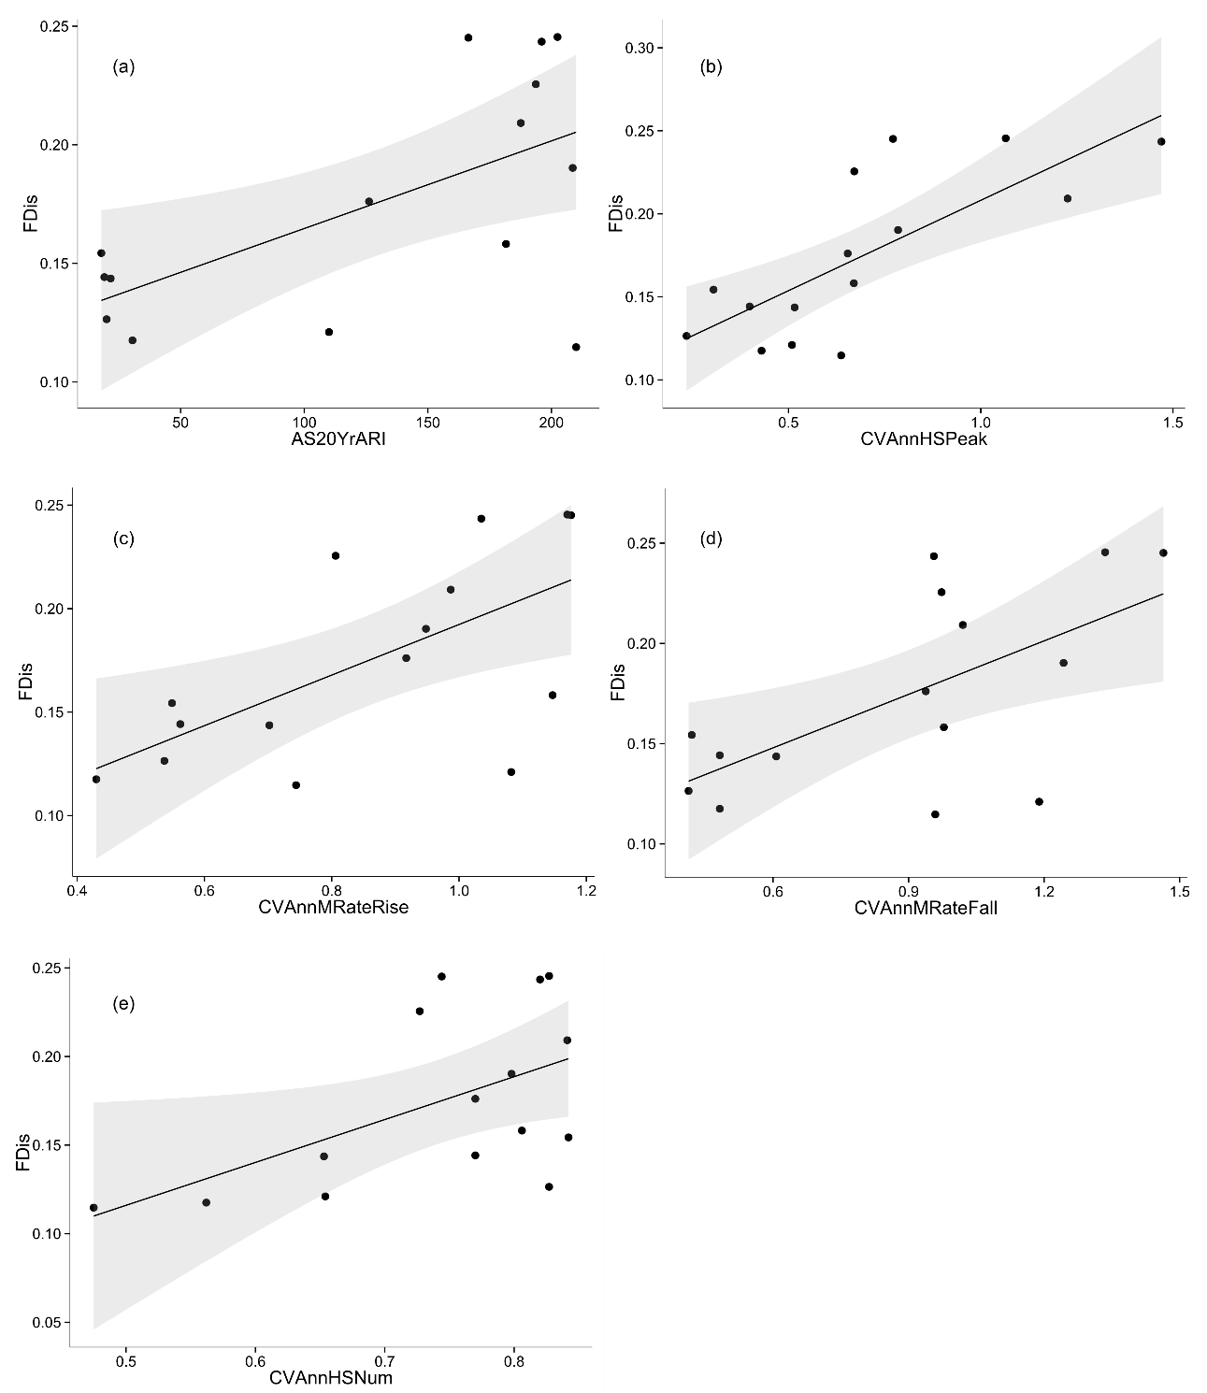
Figure 1. Relationships between FDis and hydrological metrics describing a) magnitude of the 20 year average return interval flood (AS20YrARI), b) interannual variability in high flow magnitude (CVAnnHSPeak), c) interannual variability in flood rise rate (CVAnnMRateRise), d) interannual variability in flood fall rate (CVAnnMRateFall), e) interannual variability in high flow frequency. Fitted lines depict ordinary least squares regression models. All models are linear fits. Shaded areas depict the smoothed 95% confidence interval around the regression model. All relationships shown are significant.

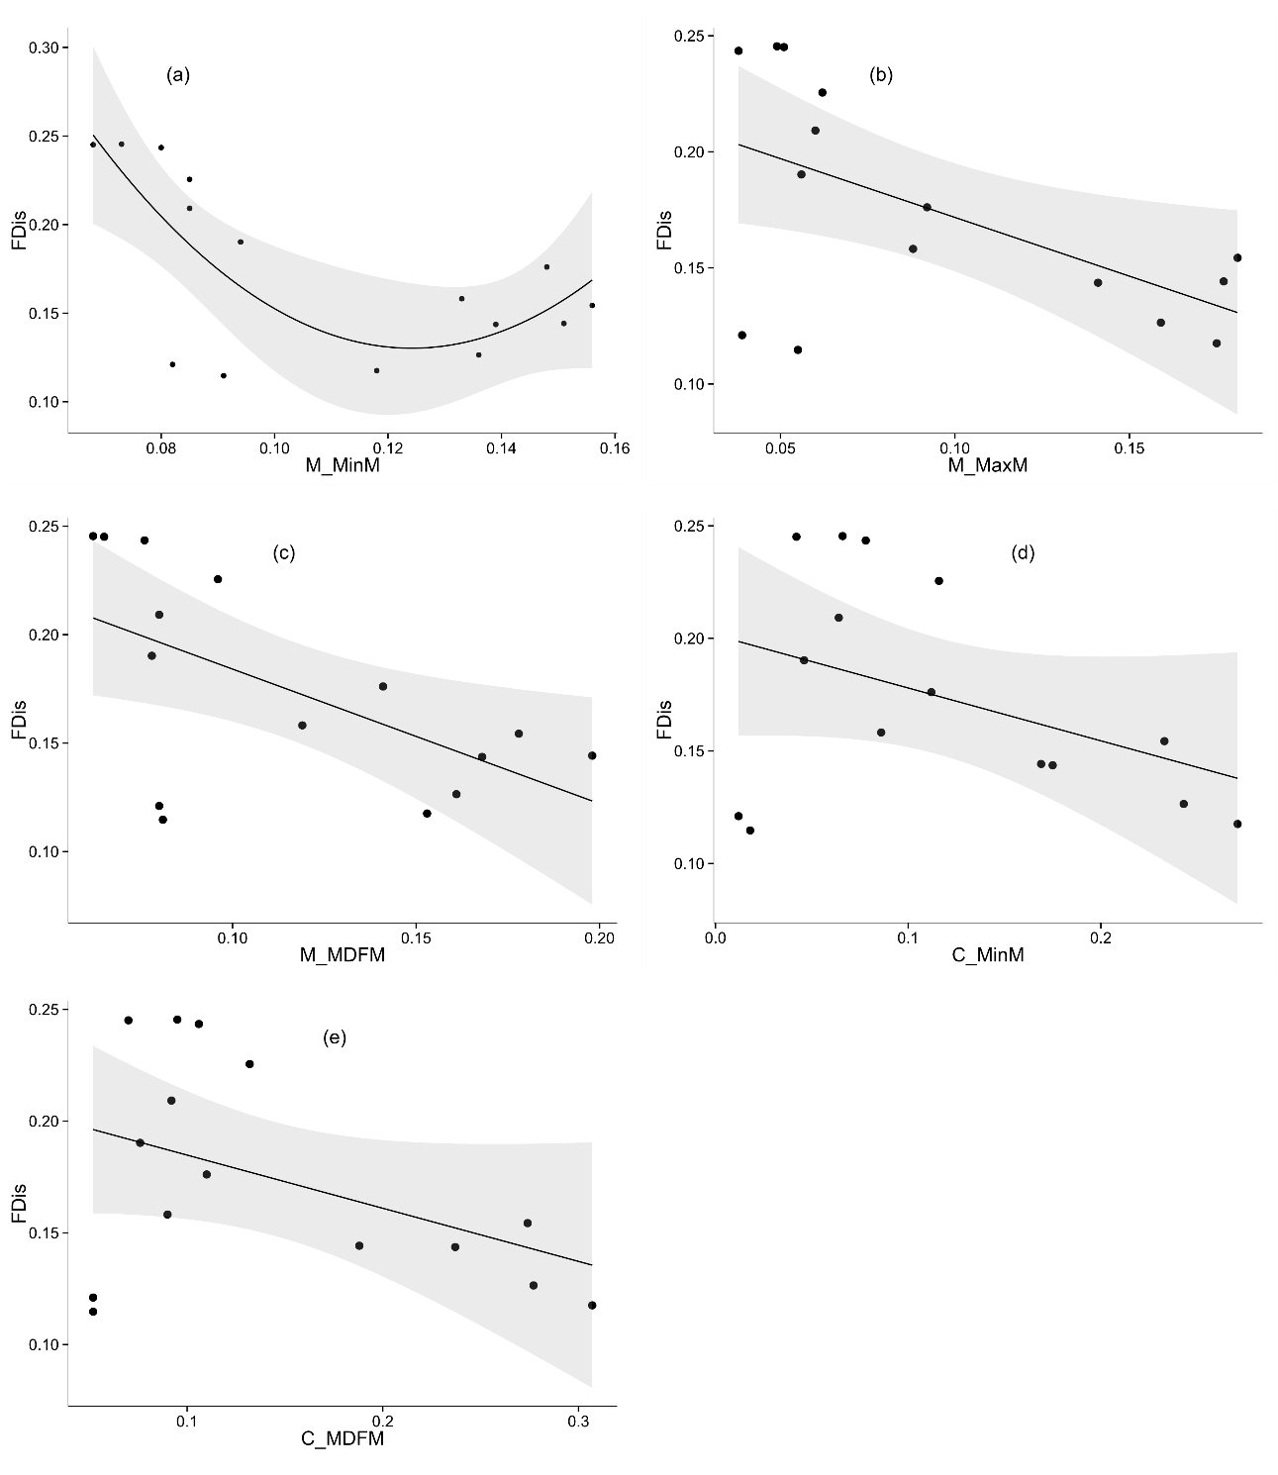
Figure 2. Relationships between FDis and hydrological metrics describing a) contingency of monthly minimum daily flow (M_MinM), b) contingency of monthly maximum daily flow (M_MaxM), c) contingency of monthly mean daily flow (M_MDFM), d) constancy of monthly minimum daily flow (C_MinM), e) constancy of monthly mean daily flow (C_MDFM). Fitted lines depict ordinary least squares regression models. a. is a quadratic fit, b. – e. are linear fits. Shaded areas depict the smoothed 95% confidence interval around the regression model. a. – c. depict significant relationships, d. and e. depict non-significant relationships (note the strong influence over the regression fit of the two points at the lower bound of FDis).

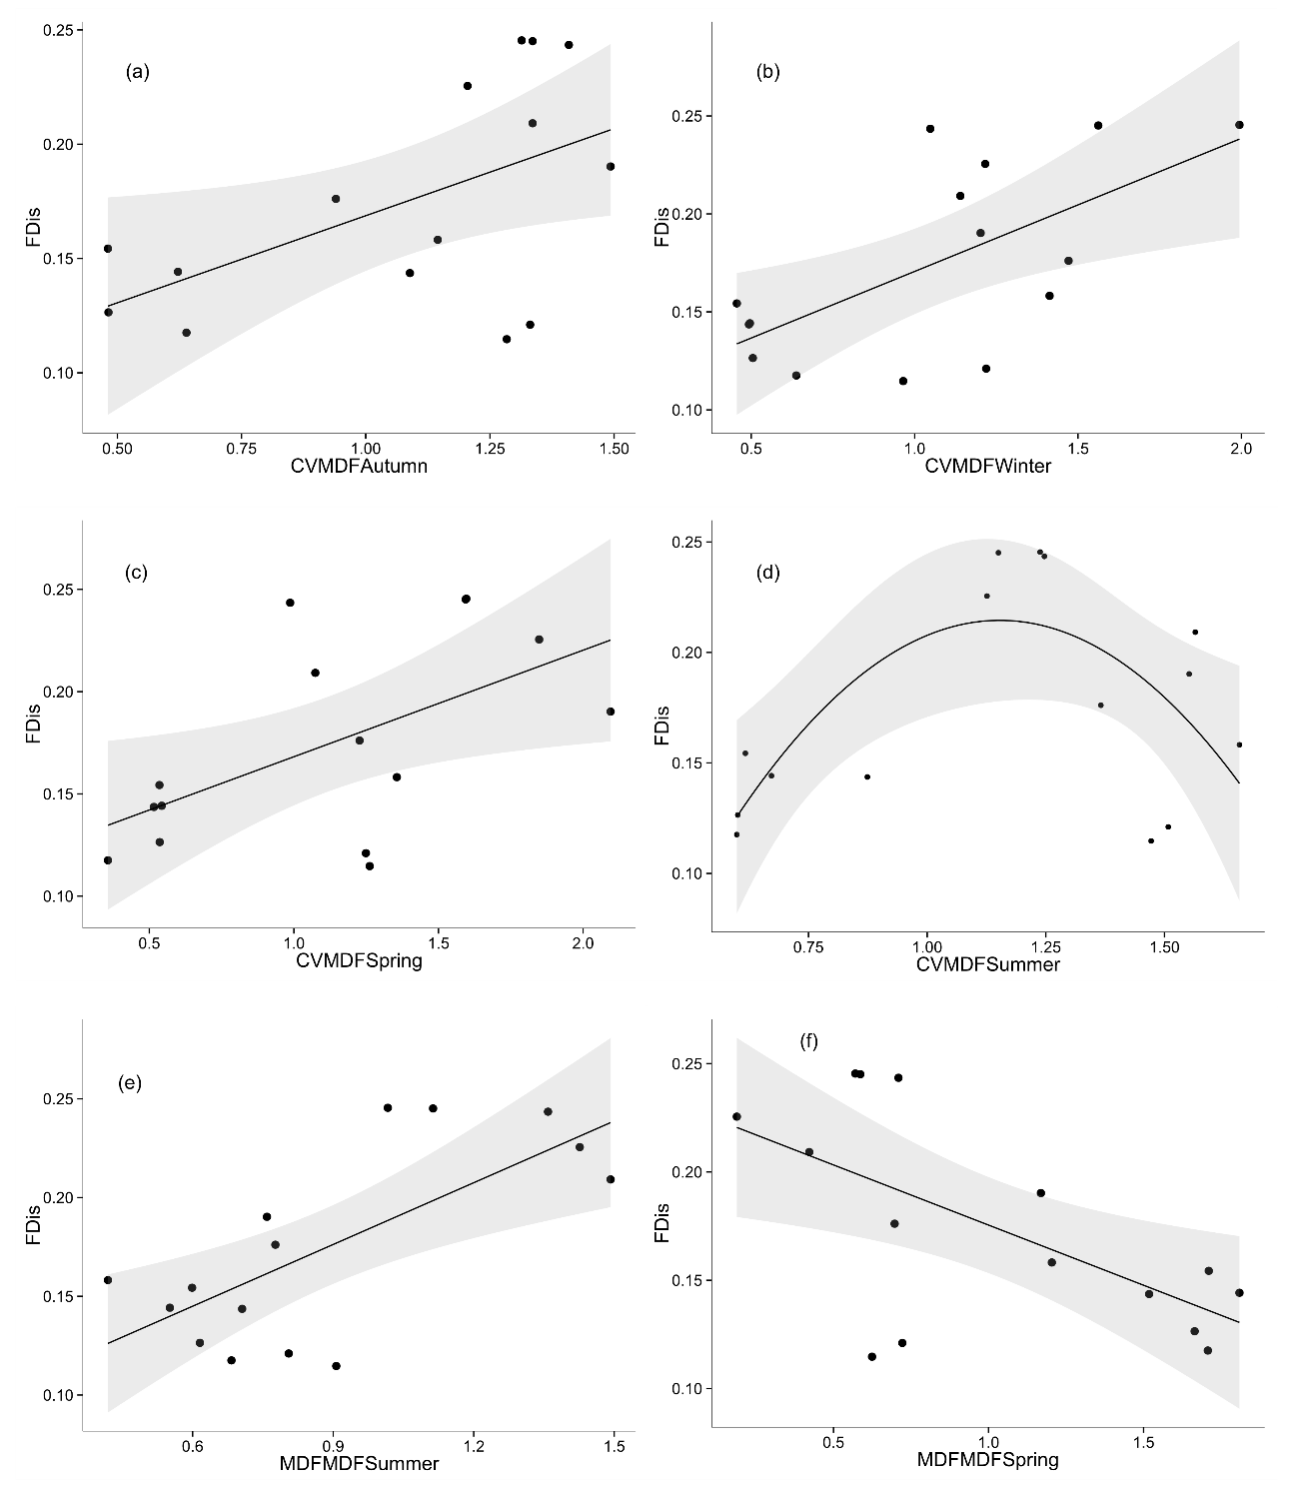
Figure 3. Relationships between FDis and hydrological metrics describing a) variability in autumn mean daily flow, b) variability in winter mean daily flow, c) variability in spring mean daily flow, d) variability in summer mean daily flow, e) mean daily flow in summer, f) mean daily flow in spring. Fitted lines depict ordinary least squares regression models. All models are linear fits except d. which is a quadratic fit. Shaded areas depict the smoothed 95% confidence interval around the regression model. All relationships shown are significant.

